PLn/PLC Enhancement  Twitter 45 min + com, col  How can you grow your PLC and build a network of teachers to support you? Twitter. From chats to networking, we cover it all.  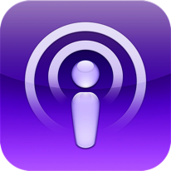  Podcasts 15-30 min com, col, ct, cr  Great way to access content when you have time. It is Professional development on demand. Connect with great teachers and speakers across the nation and share your story as well.  Discovery Ed.& Edmodo 30 min com, col, dl,ti  A great network of teachers and lesson plans to implement quickly and aligned to the CCSS. How do we maximize our time and benefit to the students?  Admin Custom Training any  Need more training than this or have an idea about implementing a whole-staff training? We will sit down with you and come up with a personalized learning or training plan fit to the needs of your students/teachers.  365 & One Drive 60-90 Min com, col, ti, dc, dl  This will revolutionize how you share files and save documents. All teachers will be trained next year, but why not get a jump on the other sites and train today?  don’t see it? Call and ask!  We pride ourselves in being able to be flexible and adaptable to any situation. We are here to help you!  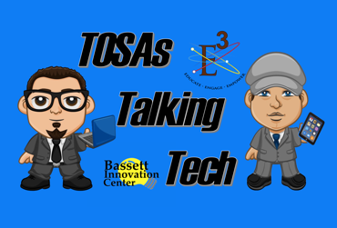  All trainings brought to you by:  Michael Jephcott and Tom Covington  Technology Integration Specialists  Check out their podcasts on Technology: bit.ly/tttbusdsite  Subscribe to the podcasts, follow these links:  iTunes: bit.ly/tttbusd  Stitcher: bit.ly/tttbusds  Catch them on twitter  @TechMikeBUSD @TechTomBUSD |  |  | 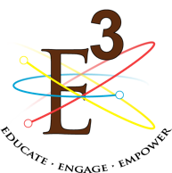  Bassett Unified School District  - Educational Services  - Technology Integration Training Options 2016  Are you looking for a way to enhance the Creativity, Collaboration, Communication and Critical Thinking in your classroom? Do you need some technology integration to spice up your PBLs? If you are, then Educational Services has you covered. We specialize in bringing 21st century technology into your classroom, lessons, planning and collaboration.  -Do you need better student presentations? How about an iMovie or Adobe Voice training for your students?  -Are you stumped at how to get student work into a visible and easily accessible space? Well then Haiku, Dropbox and OneDrive may be what you are looking for.  -Are you looking for a way to grow your Professional Learning Community? Have you tried Twitter, Podcasts or Discovery Ed?  Look inside for details on these ideas and more, all available to you through Educational Services!

Student Lessons  iMovie 60-90 min cr, com, ct, col, ti  iMovie, the iPad app. It requires at least 1:4 iPads in the classroom for training. The Basics are covered, and by the end, your students will be able to produce their own iMovie.  imovie-Trailer 30-60 mincr, com ,col ti  iMovie training focus specifically on trailers. This is a more restrictive format, but better for starting students out with movie production. It requires some planning and pre-writing, but creates professional grade trailers.1 iPad needed per group.  GreenScreen 30-60 mincr, com, ct, col, ti  iPad-centric lesson that teaches use of green screen app Veescope Live. Site licensing Available. Multiple uses for this awesome app. One iPad needed per group.  Today’s Meet 15-30 min com, col, ti  Great back channel chat app. Can be used to stimulate discussion and as a backchannel for Socratic Seminars. You can download transcripts as well to award points for participation. One device per student needed.  Adobe Voice 15-30 min cr, com, ct, ti  Adobe Voice is a free iOS app that lets you make an impact with an amazing animated video. Persuade, inform and inspire anyone online. Easy to use, great for quick presenting and awesome content.  Word, PPP/Prezi 30-60 min com, ct,  Quick user guide for students on how to maximize productivity and usage.  PBL Review/Reflect 30-60 min com, ct  Want to record your student PBL reflections? Set up an appointment with us to go over logistics. |  |  | Teacher Trainings  haiku 30 min + dl, com, col, ti  An easy way to show off student work. Digital portfolio pages are just a click away.  Safe Searching 30 min dl, dc, ti  How do you get Creative Commons images? How do you make sure the info students get is safe, accurate and true?  Class Dojo 30-60 min Pbis, com, ti  Student discipline and accountability all in the palm of your hand. iOS and Android app available  Discovery Ed 30-60 min dl, com, ct, ti  United Streaming and PCL, digital boards and awesome content. Web based and great for lesson planning and student exploration.  Dropbox 15-20 min dl, ti  Get all of your student projects in one place to download and grade and share. Excellent work around until Office365 is in place.  QR Reader 30 min dl, com, ti  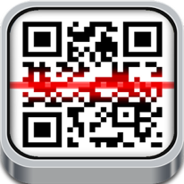  Learn to use these powerful shortcuts to get your students where you need them to be, or to direct parents to student pages/portfolios  Remind 30 min dl, com, pbis, ti  Need to contact all parents and send out messages for students? Remind is a quick and easy interface, like texting, to open up that line of communication.  Tech Ticket 10 min dl, ti  Can’t figure something out, or need something fixed? We can help you get help.  App of your Choice varies  Have an app you heard of and want to learn more? Contact us, we can teach it. I Guarantee it!

